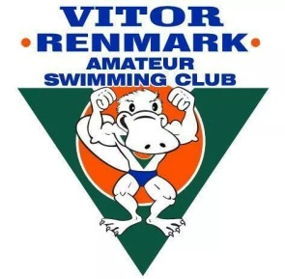

VITOR RENMARK AMATEUR SWIMMING CLUB – CODE OF CONDUCT

Swimmer

As a Vitor Renmark Amateur Swimming Club Swimmer I will…
- Follow the rules of Swimming Australia at all times.
- Give my best at all times. Be a good sport and a team player. Swim for enjoyment.
- Compete according to the competition conditions and rules. Accept the decisions or directions of the referees or officials. If in disagreement with a decision, I will raise it in an appropriate way with my coach or team manager.
- Control my temper and my language both spoken and on social media. I understand that verbal or physical abuse is not acceptable. I will not criticise by word, action or social media.
- Work equally as hard for my team as I do for myself.
- Be a good sport. Applaud good performances whether they are made by my team or for the opposition.
- Treat all swimming participants as I like to be treated myself. I will not bully or take unfair advantage of another competitor.
- Cooperate with my coaches, team mates, opponents, management, event staff and officials.
- Participate for my own enjoyment and benefit, not to satisfy the expectations of others.
- Respect the rights, dignity and worth of all participants regardless of their gender, ability, ethnicity, cultural background or religion.
- Ensure that I have adequate rest to obtain my best performance.
- Take responsibility for my actions and follow the directions of coaches and managers at all times.

Signed………….…….Full Name…………………………Date………………

