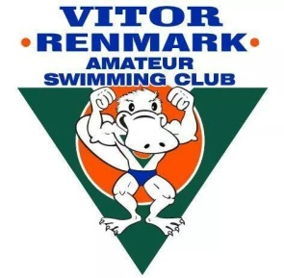

VITOR RENMARK AMATEUR SWIMMING CLUB – CODE OF CONDUCT

Parents/Guardians

As a parent/guardian of a Vitor Renmark Amateur Swimming Club Swimmer I will…
- Respect the rights, dignity and worth of all participants, regardless of their gender, ability, ethnicity, cultural background or religion.
- Encourage my child to participate in sport for their individual enjoyment, personal satisfaction and improvement.
- Remember that people participate in sport for their enjoyment and benefit, not mine.
- Encourage children to participate but will not force them.
- Focus on my child’s effort and performance, rather than winning or losing.
- Respect the decisions of officials, and encourage my child to abide by the rules and accept judgements made by officials.
- Applaud good performance and efforts from all individuals and teams. Children learn by example.
- Congratulate all participants on their performance regardless of the outcome.
- Never ridicule or scold an athlete for making a mistake. Positive comments are motivational.
- Be an example to my child and others. Appreciate good performances by all participants.
- Reject the use of violence in any form, whether it is by spectators, coaches, officials or competitors.
- Support all efforts to remove verbal and physical abuse from the sporting environment.
- Show appreciation and respect for all people involved in my child’s swimming.
- Show respect for all athletes. Without them there would be no competition.
- Encourage competitors to follow the rules and the official’s decisions.
- Not use foul language, sledge or harass other competitors, coaches or officials.
- Recognise the value and importance of volunteer officials, coaches and team managers. They give their time and resources to provide the knowledge and support for my child’s sporting benefit.

Signed………….…….Full Name…………………………Date………………

